ICS344 - Information Security – Section 4

Student Name(s) + ID(s):
Abdulwahab Badirah 202160410
Yazed almutairi 202164390
Abdulmuhaymin Althabit 202275600
Mohammed Alfaraj 202323090
DVSA Website URL:
http://dvsa-coptrz-sec-2026-157282994461-us-east-1.s3-website.us-east-1.amazonaws.com/
AWS Region: N. Virginia (us-east-1)
Date: 5/3/2026
Vulnerability Title(s):
Lesson 10: Unhandled Exceptions

Lesson 10: Unhandled Exceptions

- Goal and Vulnerability Summary
This lesson demonstrates an Unhandled Exceptions vulnerability in the DVSA application. The affected component is the API Gateway + AWS Lambda (DVSA-ORDER-MANAGER) backend request-processing path. By sending malformed input to the /order endpoint, the backend fails internally and returns a generic Internal server error instead of safely rejecting the request. The security impact is that improper error handling allows invalid input to reach deeper logic, causing unstable backend behavior and exposing poor exception management.

- Why This Works / Root Cause
The vulnerability exists because the backend does not validate user input before processing it. The Lambda function directly unserializes and processes request data without verifying whether required fields exist or are valid. When malformed input (such as null values) is sent, the backend attempts to process it and crashes instead of safely handling the error. According to the project description, this is caused by poor error handling across the Lambda and API integration path.

- Environment and Setup

- DVSA deployed in AWS (region: us-east-1)
- Backend: API Gateway + Lambda
- Target endpoint:
https://5zga32to6k.execute-api.us-east-1.amazonaws.com/Stage/order
- Lambda function:
DVSA-ORDER-MANAGER
- Logging service:
CloudWatch (/aws/lambda/DVSA-ORDER-MANAGER)
- Tool used:
curl (Command Prompt)

- Reproduction Steps

- Open AWS Console → API Gateway
- Locate DVSA API and open Stages
- Copy the Invoke URL and append /order
- Send a malformed request using curl:
curl -X POST "https://5zga32to6k.execute-api.us-east-1.amazonaws.com/Stage/order" ^
-H "Content-Type: application/json" ^
-d "{\"action\":null,\"order-id\":null}"
- Observe the API response
- Open CloudWatch logs and confirm backend invocation
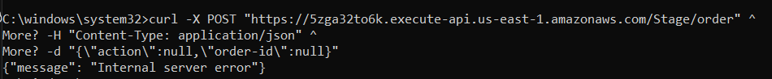
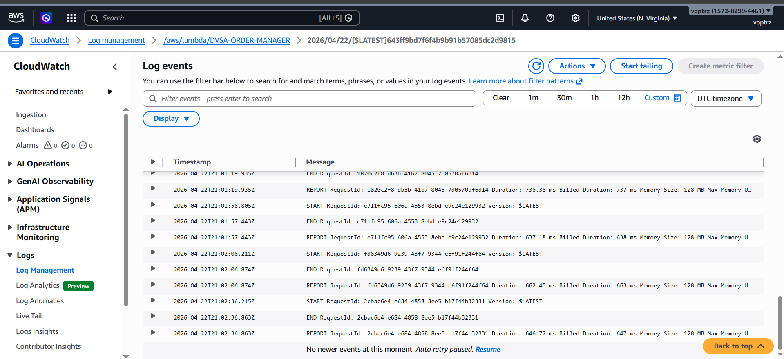 show logs

- Evidence and Proof
API Response (Before Fix)
{"message":"Internal server error"}
This proves:
- malformed input reached backend
- backend failed internally
- no safe validation occurred
CloudWatch Logs
- Log group: /aws/lambda/DVSA-ORDER-MANAGER
- Lambda invocation confirmed at test time
Even though the stack trace was not fully visible, the project notes that API Gateway may hide backend crashes behind generic errors.

- Fix Strategy / Probable Mitigation
The fix is to:
- validate input before processing
- catch exceptions safely
- return only client-safe error messages
- prevent malformed input from reaching deeper logic
As described in the lesson:
validate input before deeper processing and return only generic client-safe error messages

- Code / Config Changes
Fix applied in:
Lambda → DVSA-ORDER-MANAGER → order-manager.js
Key changes:
- Added safe parsing of request body
- Added validation for required fields (action, order-id)
- Added try/catch blocks to prevent crashes
- Returned safe error messages instead of backend failure
- Serialize removed for lesson 9 and keeping flow
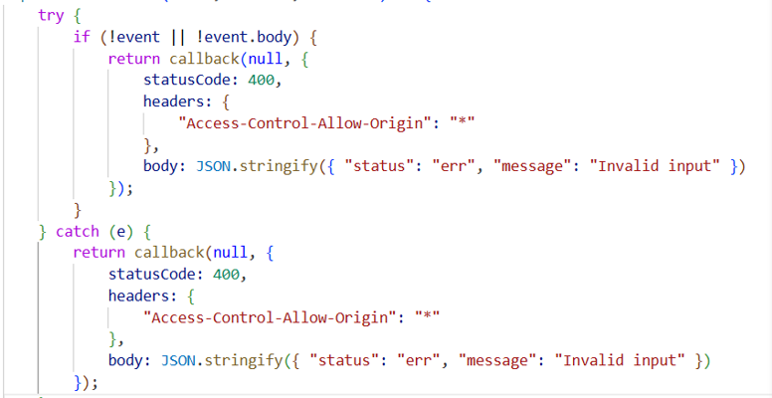
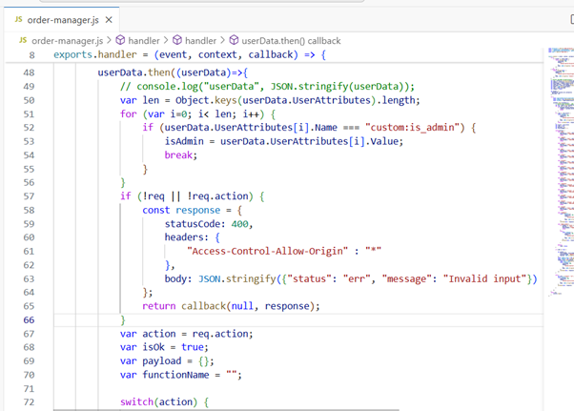

- Verification After Fix
Same test was repeated:
curl -X POST "https://5zga32to6k.execute-api.us-east-1.amazonaws.com/Stage/order" ^
-H "Content-Type: application/json" ^
-d "{\"action\":null,\"order-id\":null}"
Result After Fix:
{"status":"err","message":"Invalid input"}
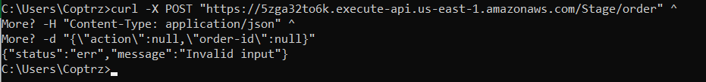
Outcome:
- no backend crash
- safe validation response returned
- vulnerability successfully mitigated

- Structured Operation and Security Analysis
Table A
Vulnerability | Intended Rule | Evidence Source | Normal Behavior | Exploit Behavior
Unhandled Exceptions | Invalid input must be rejected before backend processing | API request, CloudWatch logs | System should return safe validation error | System returned internal server error

Table B
Vulnerability | Why Deviation | Class | Fix Applied | Verification
Unhandled Exceptions | Input was processed without validation, causing backend failure | Security misuse | Added validation + error handling in Lambda | Malformed request now returns safe error

- Takeaway / Lessons Learned
This lesson highlights the importance of input validation and proper exception handling in serverless applications. Without validation, malformed input can propagate through the backend and cause failures. In AWS serverless architectures, API Gateway may hide internal errors, making it even more important to enforce validation at the Lambda level. Applying secure design principles such as validation, defensive coding, and safe error handling prevents such vulnerabilities.

